Lesson 6 : Percentages II (C)
Answer

Checkpoint 1

Simple Interest :
$$I=P×R\%×T$$
$$A=I+P$$
$A=( P×R\%×T)+P$ or $P(1+R\%×T)$
P = Principal
R = Rate
T = Time (by year)
I = Interest
A = Amount

1. Find the simplest interest of the following.
(a) Principal: $2 000; Interest rate 4% p.a.; Period: 3 years
(b) Principal: $300; Interest rate 3.5% p.a.; Period: 1.5 years
(c) Principal: $60 000; Interest rate 2% p.a.; Period: 8 months

- $\text{\$2} \text{000}×\text{4\%}×\text{3}=\text{\$240}$
- $\text{\$300}×\text{3.5\%}×\text{1.5}=\text{\$15.75}$
- $\text{\$60 }\text{000}×\text{2\%}×\frac{8}{12}=\text{\$800}$
Q1-4
Simple interest problem

2. Johnny deposits $ 2 000 in Bank A at 10 % p.a., and $ 3 500 in Bank B at 7 % p.a.
(a) Find the simple interest he will receive in Bank A each year.
(b) Find the simple interest he will receive in Bank B each year.
(c) Find the total interest he will receive each year.

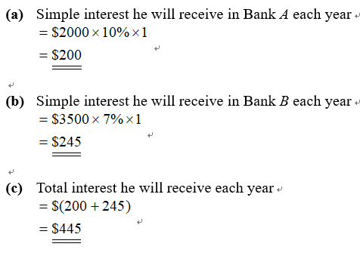




3. Raymond deposits $24 000 in a bank at a simple interest rate of 3% p.a. If he increases the deposit period from 2 years to 5 years, find the increase in the interest earned.

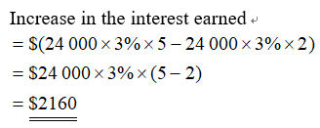

4. Shirley deposits $50 000 at a simple interest in a bank for 4 years. If the interest rate is increased from 4% to 9%, find the increase in the interest earned.

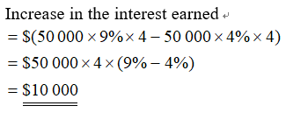

5. If $8 000 is deposited in a bank at a simple interest rate of 2% p.a., how long will it take to receive an interest of $960?

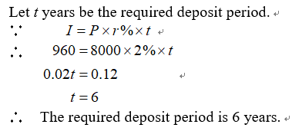
Q 5-8
Find rate/principal/time by Using Simple interest formula

6. Sam borrows $20 000 from a bank at a simple interest rate and he has to repay an amount of $21 200 after 2 years. What is the annual interest rate?

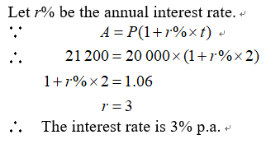

7. If $32 000 is deposited in a bank at a simple interest rate of 3% p.a., how long will it take to receive an amount of $34 880?

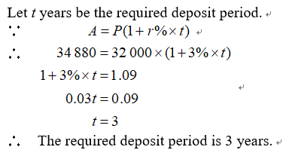

8. Alex borrows $\$ P$ from a bank at a simple interest rate $5\%$ and he has to repay an amount of $\$ 19550$ after $3$ years. Find the value of $P$.

$$19550=P\left(1+5\%×3\right) \\ P=\frac{19550}{1.15} \\ P=17000$$

Q 9-12
Advanced Simple interest problem
9. A sum of $12 000 is deposited at a simple interest rate of 3% p.a. For each of the following deposit periods, find
(i) the simple interest,
(ii) the amount.
(a) 2.5 years
(b) 18 months

Hints: 18 months = ? year

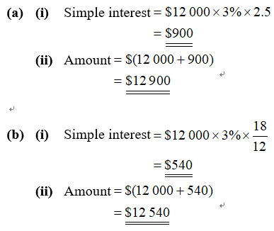


10. Mrs. Yeung deposits some money in a bank at an interest rate of 3% p.a.. She gets $600 simple interest for the first quarter of the year.
(a) How much does Mrs. Yeung deposit at the beginning?
(b) If the interest rate is increased by 3 % p.a., find the simple interest that she will get for the remaining 3
quarters of the year.

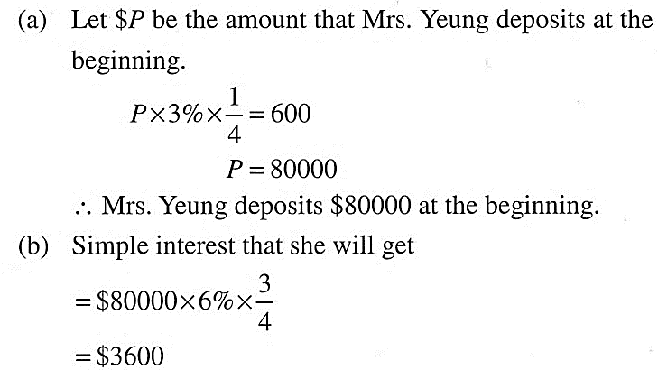


11. If the interest rate is 12% p.a. and the simple interest repaid after 15 months is $1 500, find the principal borrowed.

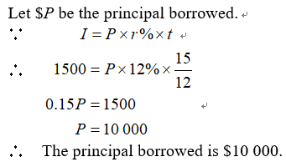

12. Maggie deposits $15 000 in Bank A at a simple interest rate of 6% p.a. for 1.5 years, then she deposits the amount in Bank B at a simple interest rate of 3% p.a. for 2 years. Find
(a) the amount she obtained from Bank A,
(b) the amount she obtained from Bank B,
(c) the total interest earned from both banks.

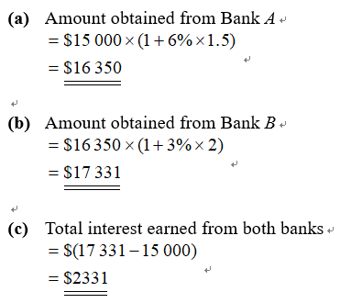



Checkpoint 2

Compound Interest :
$$A=I+P$$
$$A= P{(1+\frac{R\%}{n})}^{t}$$
$$I=P{(1+\frac{R\%}{n})}^{t}-P$$
P = Principal
R = Rate
n = number of Times (by year)
t = number of times during the period
I = Interest
A = Amount

13. $10 000 is invested at 10% p.a. for 3 years. If the interest is compounded yearly, find
(a) the amount,
(b) the compound interest after 3 years.

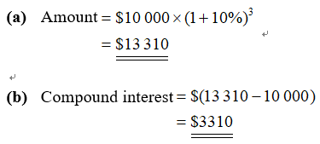

Q 13-21
Compound interest problem

14. Tracy deposits $30 000 in a bank at 3% p.a. compounded yearly, find the compound interest after 4 years.

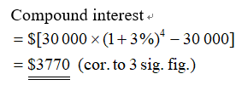

15. Mr Tam invests $8 000 for 3 years at 12% p.a. Find the amount he will obtain if the interest is compounded
(a) half-yearly,
(b) quarterly,
(c) monthly.

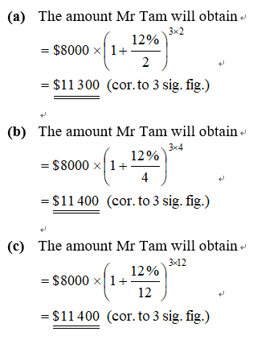



16. Kate deposits $P in a bank at 6% p.a. and the interest is compounded half-yearly. If she obtains an amount of $23 880 after 3 years, find
(a) the value of P,
(b) the compound interest earned.

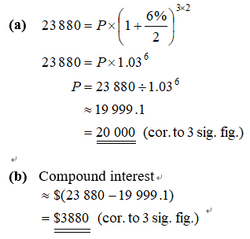


17. Steve deposits a sum of money in a bank at 8% p.a. and the interest is compounded yearly. If he obtains an amount of $99 144 after 2 years,
(a) find the principal,
(b) If the annual interest rate is unchanged and the interest is compounded monthly, find compound interest he will obtain after 9 months.

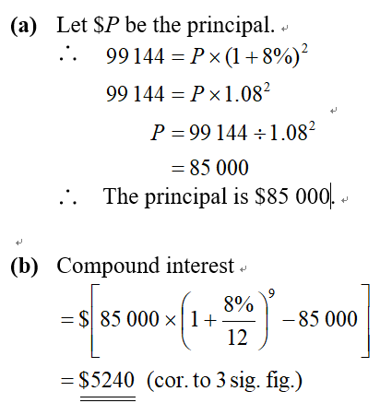


18. Alice deposits $30 000 individually in two banks A and B. Bank A offers an interest rate of 6% p.a. compounded yearly, while bank B offers the same annual interest rate compounded quarterly. Assume that both deposits are for 3 years. Find
(a) the amount she obtained from bank A,
(b) the amount she obtained from bank B,
(c) the difference in the amounts she obtained from the two banks.

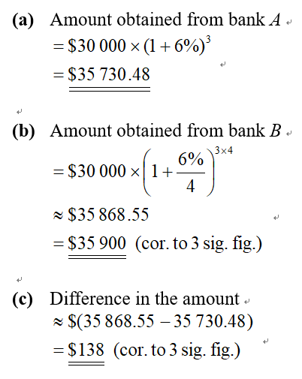



19. A principal of $50 000 is deposited for 2 years at an interest rate of 6% p.a.. Find the amount if it is compounded:
(a) half-yearly;
(b) quarterly;
(c) monthly;
(d) daily (assume there are 365 days in a year).
(Correct your answers to the nearest dollar.)

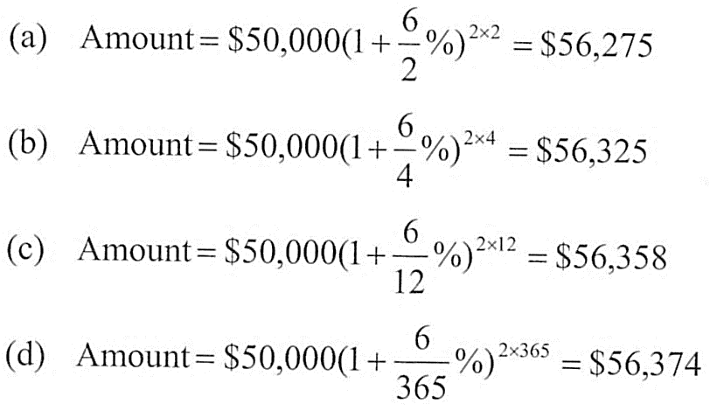

20. Daniel deposits $48 000 in a bank for 2 years and the interest is compounded monthly. If the interest rate is increased from 4% to 5%, find the increase in the amount obtained.

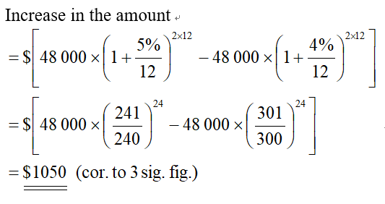

21. Chris deposits $5 000 in bank A at 10% p.a. compounded half-yearly for 2 years, then he deposits the amount in bank B at a simple interest rate of 5% p.a. for $\text{1}\frac{\text{1}}{\text{2}}$ years. Find
(a) the amount he obtained from bank A,
(b) the total interest earned from two banks.

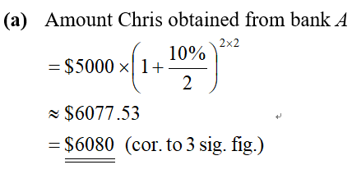
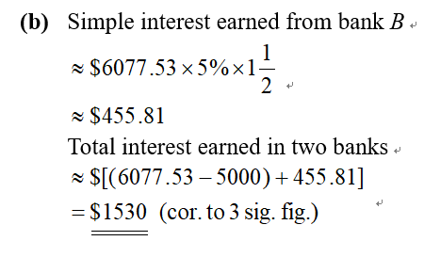

22. $3 000 is deposited for 5 years at an interest rate of 10% p.a., find the different between the simple interest and the compound interest compounded yearly.

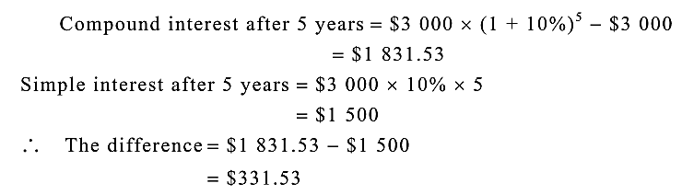

Checkpoint 3

A man borrows $\$ 5 000$ from a bank at $12 \%$ p.a., compounded monthly. He repays $\$ 500$ at the end of each
month. Find how much he still owes the bank after the second repayment, correct to $1$ decimal place.

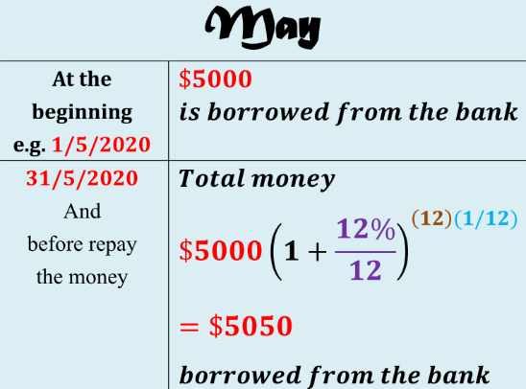
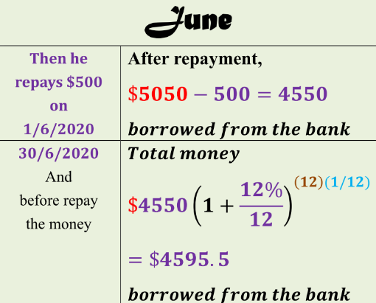
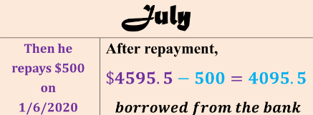

23. A man borrows $20 000 from a bank at 10% p.a. and repays $5 000 at the end of each year. Find the amount he still owes after the fourth payment.

Q 23-25
Repay money problem

24. A man borrows $5 000 from a bank at 12% p.a., compounded monthly. He repays $500 at the end of each month. Find how much he still owes the bank after the second repayment, correct to 1 decimal place.

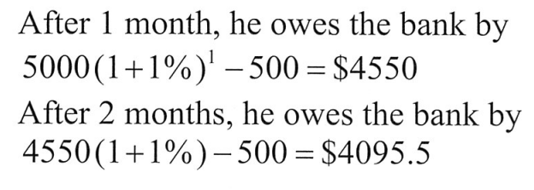

25. Jason borrowed $35 000 from a bank at an interest rate of 18% p.a. compounded monthly, and he had to repay $10 000 at the end of each month.
(a) How much, correct to the nearest dollar, did he owe the bank at the beginning of the third month?
(b) How many repayments were needed to settle the loan?

Checkpoint 4

Miss Kwan’s total annual income for the year $2019/20$ is $\$ 300 000$. If her salaries tax allowance is
$\$ 120 000$, how much salaries tax should she pay
Step 1 Covert total annual income into Net chargeable income
$Net chargeable income= 300 000-120 000$
$$=\text{\$ 180 000}$$
Step 2 How many $\$ 50 000$ can be divided from
Net chargeable income?
ANS: $3$ and the remainder is $\$ 30 000$
Step 3 Calculation
$∴ Miss Kwan's salaries tax payable$
$=50000×2\%+50000×6\%+50000×10\%+30000×14\%$
$=\$ 13 200$

Net chargeable income | Tax rate | Salary tax
On the first $\$ 50 000$ | $$2 \%$$ | $$\$ 1 000$$
On the next $\$ 50 000$ | $$6 \%$$ | $$\$ 3 000$$
On the next $\$ 50 000$ | $$10 \%$$ | $$\$ 5 000$$
On the next $\$ 50 000$ | $$14 \%$$ | $$\$ 7 000$$
Remainder | $$17 \%$$

26. The net chargeable income of Thomas is $155 000. How much salaries tax should he pay?

Net taxable income $=\$ 155 000$
$=\$ (50 000+50 000+50 000+5 000)$
Salaries tax $=\$ 50 000×2\%+\$ 50 000×6\%+\$ 50 000×10\%+\$ 5 000×14\%$
$$=\$ 9 700$$

27. If the basic allowance for a single person is $108 000, find the amount of salaries tax for each of the following monthly income.
(a) $10 000
(b) $63 000

(a) Net taxable income$=\$ 10 000×12-\$108 000=\$ 12 000$
Salaries tax$=\$12 000×2\%=\$ 240$
(b) Net taxable income $=\$ 63 000×12-\$108 000=\$ 648 000$
$=\$ (50 000+50 000+50 000+50 000+448 000)$
Salaries tax $=\$ 50 000×\left(2\%+6\%+10\%+14\%\right)+\$ 448 000×17\%$
$=\$ 16 000+76 160$
$=\$ 92 160$

28. Miss Lo’s salaries tax payable charged at progressive rates is $240 for this year. If she has an allowance of $216 000, find her annual income.

